1. 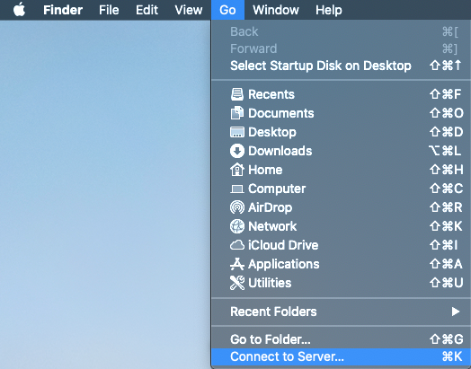Start in Finder (click on desktop)
2. From the Go menu select Connect to Server…
3. 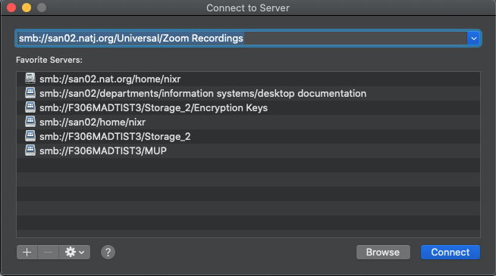Type in smb://san02.natj.org/Universal/Zoom Recordings and click connect
4. The mapped folder should appear on your desktop and/or locations panel.

