- Click on this folder looking thing on your dashboard
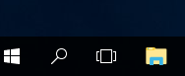
Or

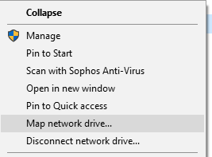
- Right click on “This PC” and select Map network drive…
On windows 7, this item will be called “Computer”, same steps, different name…

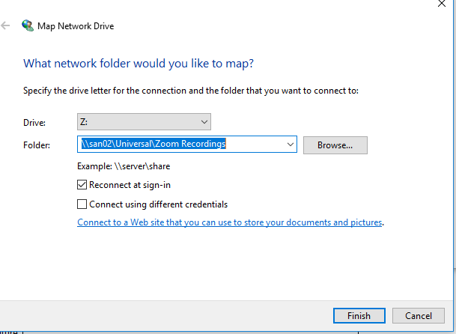
- Type in \\san02\Universal\Zoom Recordings and click finish

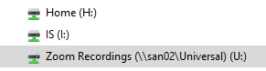
- The mapped folder is in the quick access panel (same as H & I)

