**RESEARCH LAB MICROSITE TEMPLATE**

Please send this completed document to Jacob Williams at [WilliamsJ@NJHealth.org](mailto:WilliamsJ@NJHealth.org?subject=Web%20Bio)

For questions or more information, contact Jacob Williams at 303.728.6573.

 [View Lab Microsite Template Example Here](https://www.njhealth.org/chulab)

|  |  |
| --- | --- |
| **Lab Website Name:** |  |
| **Principal Investigator:**  *Include link to their bio* |  |
| **Admin or Contact Person for Web Updates:**  *Include phone number & Email* |  |
| **Email Address to use for Contact Inquiry Form**  *This is the email address that form inquiries will be sent to.* |  |
| **When would you like this completed by for review?** |  |
| **Microsite Banner Image**  *Image must be high resolution (at least 888 x 507) and horizontal.*  *If you have an image in mind, attach to email.*  *If you’d like us to search for a stock photo for you, please include the image concepts you’d like. For example: heart, lungs, researcher with microscope, etc.* |  |
| **Call to Action Box (Purple Box Right of Banner)**  *Include the 3 pages (tabs) you’d like to feature or featured copy you’d like in this box. For example: job opportunity you’re hiring for or general copy* |  |

**Example with copy:**

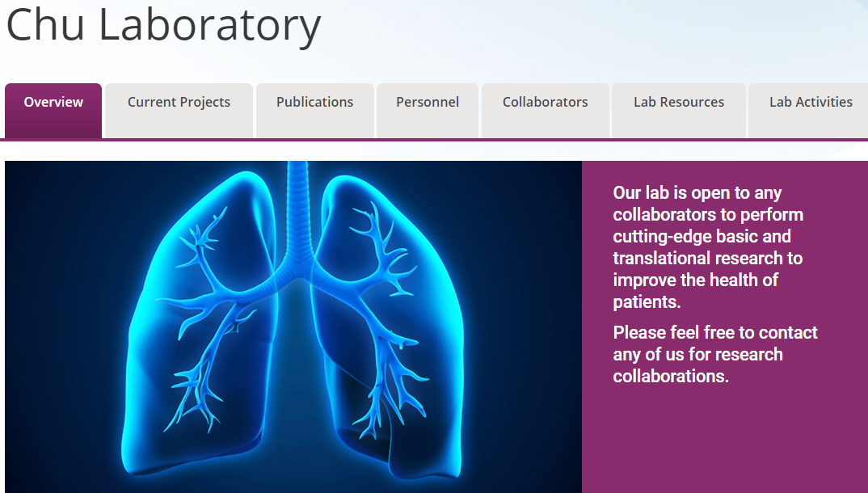

**Example with buttons:**

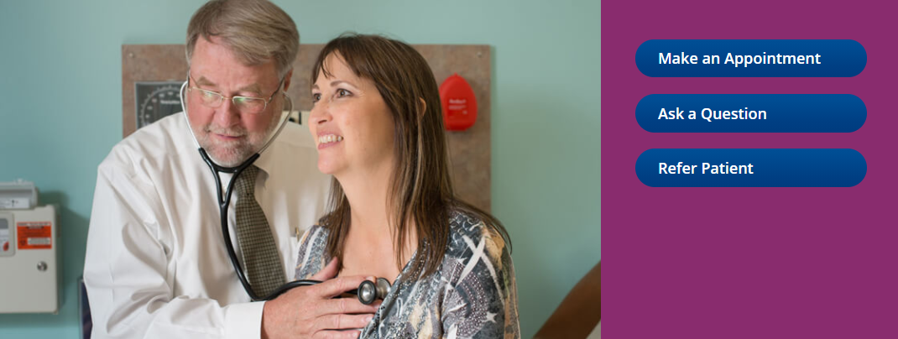

**HOMEPAGE (OVERVIEW TAB):**

**Overview of Research**

*Approximately 200 words*

**Lab Resources & Services – Teaser blurb on homepage**

*Describe in 1-2 sentences what your lab has to offer and where it is located.*

*List these items and provide descriptions, as necessary.*

**LAB RESOURCES & SERVICES TAB (New page):***Describe these items.*

**Current Projects (Specific Research Areas) – Teaser blurb on homepage**

*List projects titles.*

**CURRENT PROJECTS & GRANT INFORMATION TAB (New page):***Provide full descriptions of the projects to link to and list grants awarded to the researcher.*

**Lab Personnel – For homepage**

*List staff, interns, etc.*

**LAB PERSONNEL TAB (New page):***Provide paragraph mini-biographies for each staff member.*

*Include: name, professional title (MD, PhD), job title (Instructor), phone number, email, education (list chronologically), and background information (1-5 sentences preferably).*

*Include professional photo, if you need to get a photo taken, please contact Eliza Nolte, the medical photographer, to schedule a photo session.*

**COLLABORATORS (New page):**

*List the names from within NJH and/or names of collaborators outside NJH, include link to online bio if available.*

*For collaborators outside NJH, include name, title, link to professional profile if available, name of institution they work at, and city and state.*

*Optional: Provide brief descriptions of what each collaborator is doing.*

**Publications – For homepage**

*List one or two to feature on the homepage.*

**PUBLICATIONS TAB (New page):***If you have a full list of recent publications a new page can be created.*

*Please include PubMed ID # or links to the publication.*

**\*OPTIONAL* CONTENT ITEMS**

**Training/Job Opportunities in the Lab**

*List and describe opening opportunities and/or general blurb for inquiry.*

**Diagrams/Photos**

*Provide any photos or diagrams of research being done in your lab.*

**Lab Activities or Lab Life**

*This can be a fun photo gallery showcasing photos from lab outings, researchers having fun in the lab, etc.*

*Provide any other information about your lab that you would like to include.*